**DAILY ONLINE ACTIVITIES SUMMARY**

|  |  |  |  |  |  |  |  |  |
| --- | --- | --- | --- | --- | --- | --- | --- | --- |
| **Date:** | **30/05/2020** | | | | | **Name:** | **Katira Krishna J** | |
| **Sem & Sec** | **8th A** | | | | | **USN:** | **4AL16CS045** | |
| **Online Test Summary** | | | | | | | | |
| **Subject** | | **No test Conducted** | | | | | | |
| **Max. Marks** | | **-** | | **Score** | | | **-** | |
| **Certification Course Summary** | | | | | | | | |
| **Course** | **Machine learning with python** | | | | | | | |
| **Certificate Provider** | | | **Cognitiveclass.ai** | | **Duration** | | | **5 Hours** |
| **Coding Challenges** | | | | | | | | |
| **Problem Statement: Gnome sort using python** | | | | | | | | |
| **Status: Completed** | | | | | | | | |
| **Uploaded the report in Github** | | | | | **yes** | | | |
| **If yes Repository name** | | | | | **Krishna_Katira** | | | |
| **Uploaded the report in slack** | | | | | **yes** | | | |

Online Test Details:

Not Conducted

Certification Course Progress:

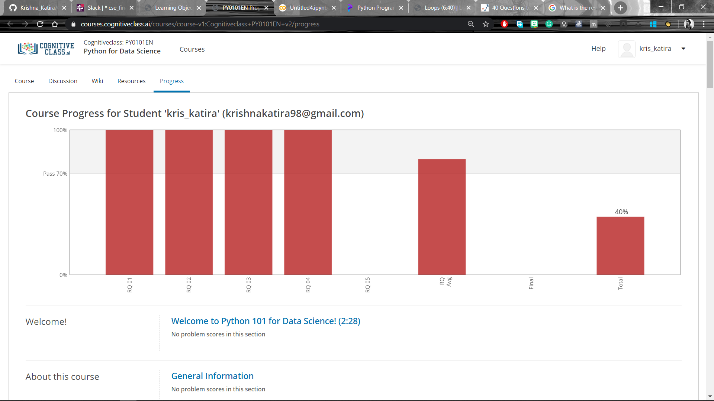

Coding Challenges Details:

**program1**

def gnomeSort( arr, n):

    index = 0

    while index < n:

        if index == 0:

            index = index + 1

        if arr[index] >= arr[index - 1]:

            index = index + 1

        else:

            arr[index], arr[index-1] = arr[index-1], arr[index]

            index = index - 1

    return arr

arr = [ 34, 2, 10, -9]

n = len(arr)

arr = gnomeSort(arr, n)

print "Sorted seqquence after applying Gnome Sort :",

for i in arr:

    print i,